Q1 — First Airflow Pipeline
Objective: Create a DAG that runs daily at 8:00 AM
Tasks:
- Create a DAG named first_pipeline.
- Add a task that prints 'Data Pipeline Started'.
- Add a task that waits for 10 seconds.
- Add a final task that prints 'Data Pipeline Completed'.
- Validate DAG execution from the Airflow UI.

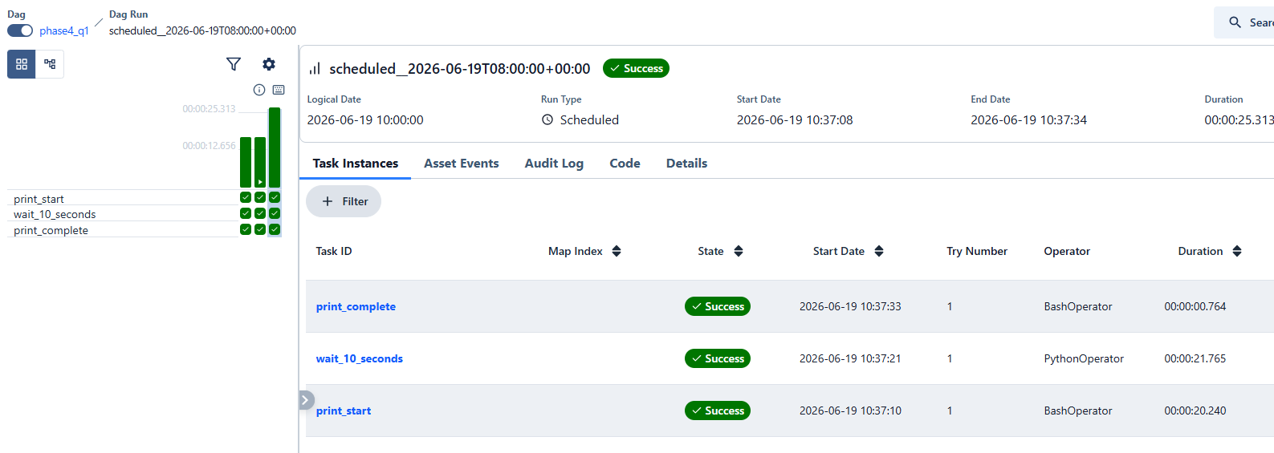

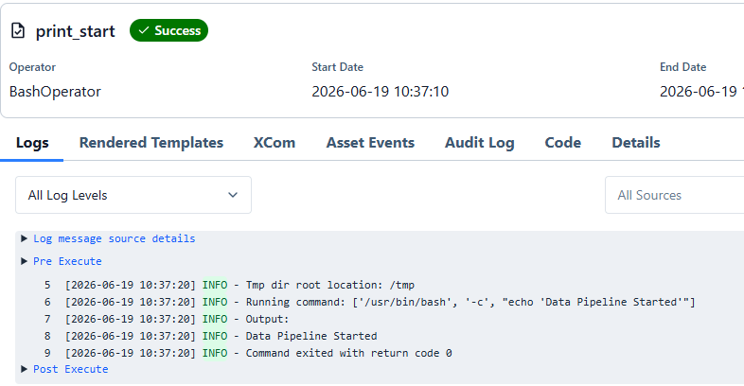
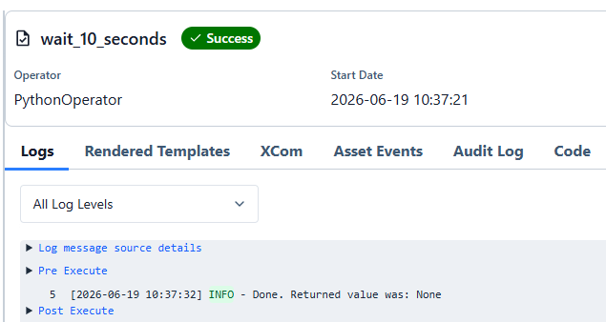
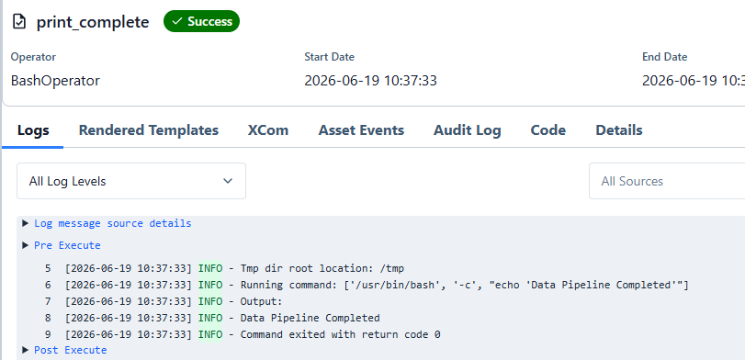

Q5 — Snowflake ETL Pipeline
Objective: Load and transform data in Snowflake
Tasks:
- Upload a CSV file to Snowflake.
- Create a SnowflakeOperator task.
- Execute transformation SQL.
- Generate a row-count report.

Expected Outcome: Transformed data available in Snowflake
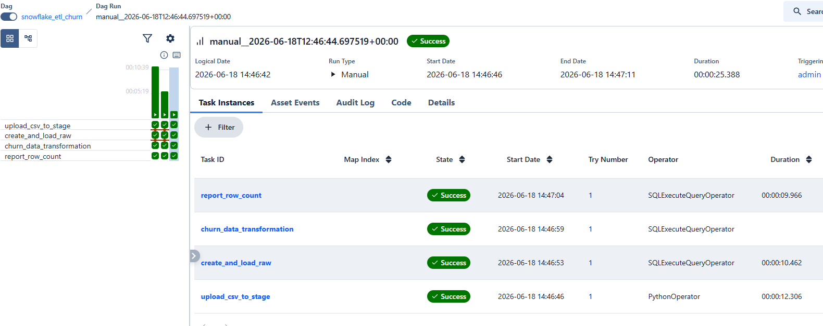
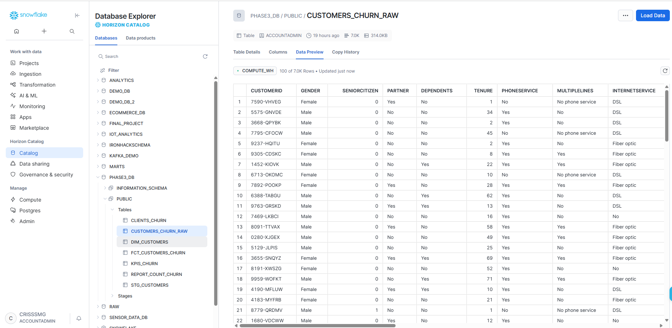
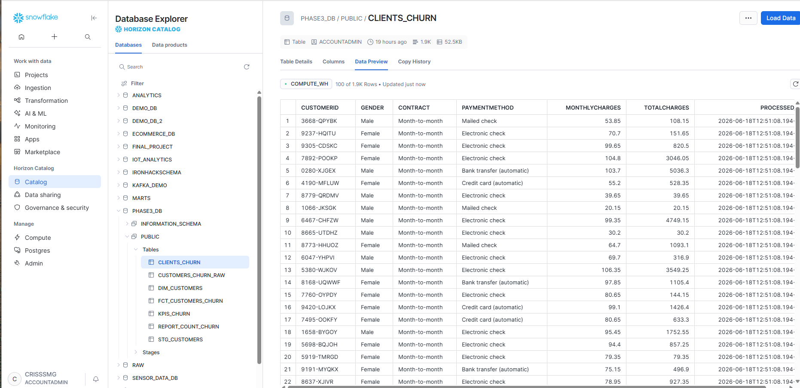
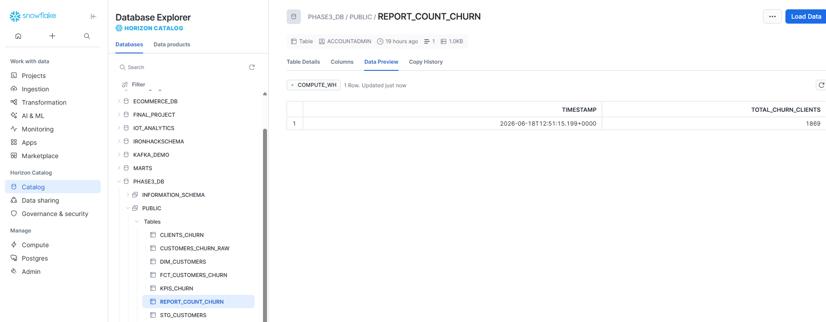

Q7 — Customer Churn Data Mart
Objective: Build an end-to-end dbt project
Tasks:
- Create staging models.
- Create intermediate models.
- Create fact and dimension tables.
- Generate customer churn KPIs.
- Document models.

Expected Outcome: Star schema and churn mart available.
Q8 — Airflow + dbt Integration
Objective: Orchestrate dbt using Airflow
Tasks:
- Create Airflow DAG.
- Execute dbt run.
- Execute dbt test.
- Capture logs.
- Configure failure notifications.

Expected Outcome: Fully orchestrated ELT workflow.

